<https://azure.microsoft.com/en-us/documentation/articles/automation-create-runbook-from-samples/>

Create Azure Automation Account

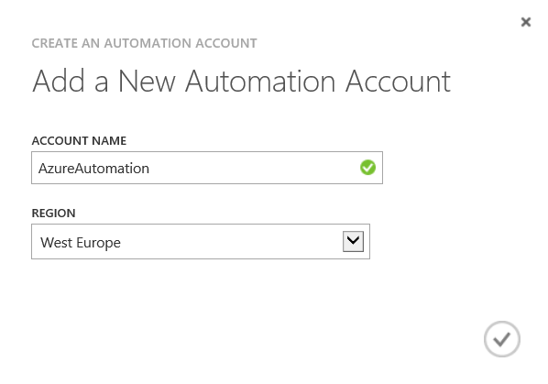

Under Assets for the Account click Add Setting at the bottom menu

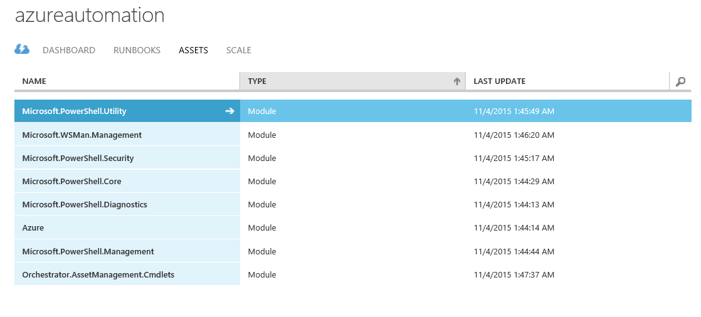

Click Add Credential

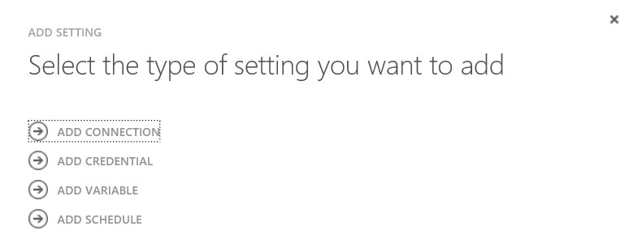

Choose Credential type – Windows PowerShell Credential

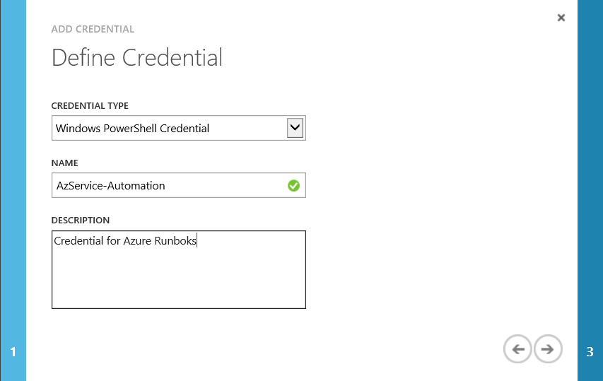

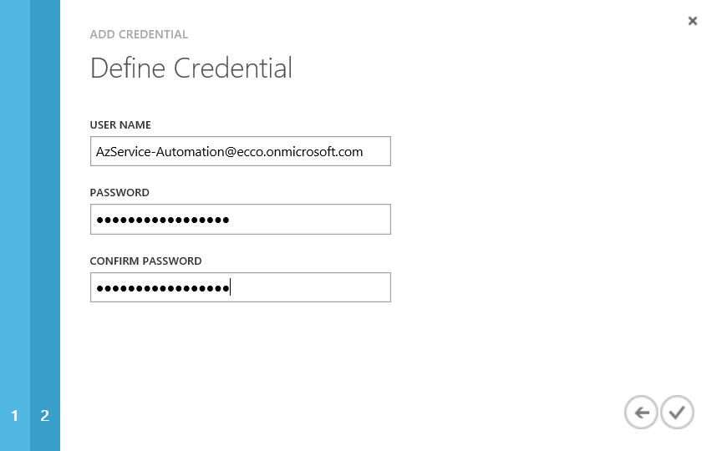

Credentials will be show under Assets

